STRATHEARN WOOL TRYST 2014

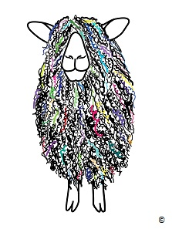
EXHIBITOR APPLICATION FORM
EXHIBITOR TRADE NAME
CONTACT NAME
ADDRESS
TELEPHONE NO
EMAIL
WEBSITE
TWITTER
FACEBOOK
DESCRIPTION OF BUSINESS
TYPES OF GOODS/SERVICES

SPECIAL CONSIDERATIONS
PAYMENT: Cheque/Paypal
£40 per Stall/Stand

